-TOM Space Range & Display-

Ranges in Progress
Business System Design

Author: Rakesh Roshan
Date: 10/04/07
Version: 0.5 – Draft

Authority: Janet Smith (Programme Director, IOD Space Range & Display Programme)
Signature:

Authority: Chris J Barber (Project Manager, IOD Display Stream)
Signature:

Authority: Emma Kenyon (Project Manager, IOD End-to-End Space Range & Display Process)
Signature:

Authority: Eva Hotmarova (Group IT Project Manager, Space Range & Display)
Signature:

Contents
1 Management Summary 3
1.1 What does the system do? 3
1.2 Why are we making changes? 3
1.3 What is the scope of the changes? 3
1.4 What are the timescales for implementation? 3
1.5 What assumptions have been made in the design? 3
2 System Design 4
2.1 System Context Diagram 4
2.2 System Changes 5
2.2.1 Screen border 5
2.2.2 Display Group Summary 7
2.2.3 Range Status Summary 9
2.2.4 Range Status Details 11
2.2.5 Store Cluster Summary 13
2.2.6 Level of Change 15
2.2.7 Product Summary 17
2.2.8 Product Details 19
2.2.9 Product Matrix 21
2.2.10 Product Sales 23
2.2.11 Reconcile Store Clusters 25
2.2.12 Reconciliation Errors 27
2.2.13 Authorise Store Clusters 30
2.2.14 Authorise Ranges 32
2.2.15 Authorisation Report Selection 33
2.2.16 Authorisation Report 34
2.2.17 Audit Trail 36
2.3 Integration 38
2.3.1 Existing interfaces to be used as is 38
2.3.2 Existing interfaces to be changed 38
2.3.3 New interfaces 38
2.3.4 Existing Interfaces not required for TOM 38
3 Requirements Catalogue 40
4 Screenshots showing system changes 41

Management Summary

What does the system do?
Ranges in Progress is an application that has been developed to help reconciliation between the UK Ranging & Planogramming systems. It also enables users to authorise ranges upon successful completion of reconciliation.
Ranges in Progress will allow the display team to view “in progress” range data held in CRDB, reconcile Ranges & Planograms, manage the authorisation of ranges and plans, and control the transmission of authorised ranges to downstream systems

Why are we making changes?
The UK system is to be used as a basis for The Operating Model version, but some changes are required to make it suitable, such as changing some of the terminology.
Also, because the The Operating Model architecture is different, some of the interfaces will have to be changed.

What is the scope of the changes?
The scope of the changes, as described in this document, only relates to the Must Have requirements for TOM Phase 1. Please refer to the requirements catalogue in section 3 for details.

What are the timescales for implementation?
The system is planned to go into UAT in June 2007.

What assumptions have been made in the design?
- Display Group Management will be used to create separate display groups for promotion ends
- Promotional Ranges will NOT be created in the Ranging System
- Promotional ranges must be authorised in RIP
- Non-ranged Display Groups will be used for Promotional Range Events, but there may be other types of Event that also use non-ranged Display Groups
- The RIP system should handle all the ranges in a consistent manner

System Design

System Context Diagram
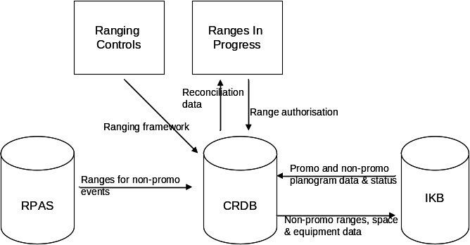

- The ‘ranging framework’ of future-dated Range Event, Display Group, Store Clusters and Supported Range Classes is fed from the Ranging Controls applications into the Commercial Range Database (CRDB)
- Ranges for ranged events are fed from RPAS to CRDB and onward to IKB for planogramming together with space and equipment data
- Ranges for promotional and other non-ranged events are created directly in the Planogram System
- Planogram data and status for all range events is fed from IKB to CRDB for reconciliation and authorisation in RIP

System Changes

The following sections describe the changes required to the system functions and screen designs.

Screen border
The screen border shows the title of the system, the Tesco logo, and the navigation pane.

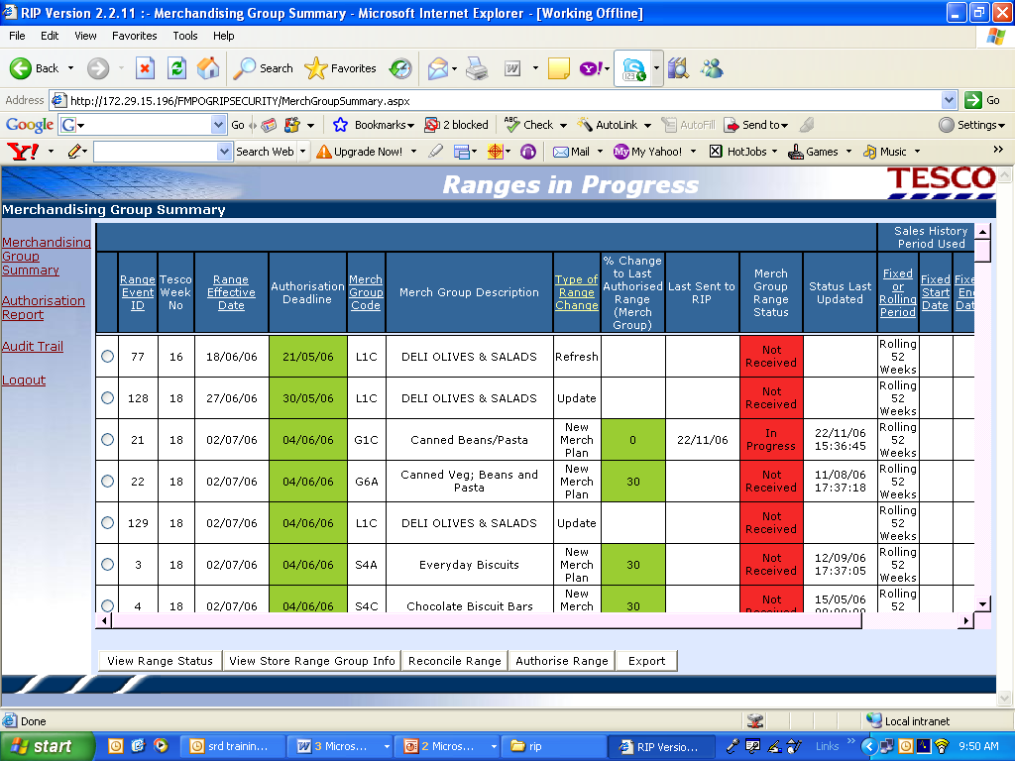

Changes Required
The changes required to the screen are as follows:

Item | As Is | To Be
Tesco Logo | Tesco | Blank
System Title | Merchandising Group Summary | Display Group Summary
Merchandising Group Page Link | Merchandising Group Summary | Display Group Summary

Display Group Summary
The purpose of this screen is to display a summary of data for the Display Group range events that have been scheduled on the Space, Range and Display schedule.
Promotional and other non-ranged event data will appear on this screen. The Display Group Range Status column will never show ‘In Progress’, as there will be no range from ranging system so the only applicable statuses will be ‘Not Received’, ‘Authorised’ or ‘Cancelled’.
Non-ranged Display Groups will have a flag set against them in CRDB to indicate whether or not they are ranged in the Ranging System or only planogrammed. An additional column is to be added to this screen so the user can see those Display Groups that are not ranged in the Ranging System.
All error messages will be changed to be consistent with TOM terminology (see Requirements Catalogue at Section 3 for appropriate terms).

Screen layout

Changes Required
The changes required to the screen are as follows:

Item | As Is | To Be
Merchandising Group Code Field | Merchandising Group Code | Display Group Code
Merchandising Group Description Field | Merchandising Group Description | Display Group Description
Type of Range Change field | Refresh, Update, Out of Cycle, New Merchandising plan | Major, Minor, Essential, Promotion. This should depend on the types set up in the Schedule, and should not be hard-coded as the only options available
% Change to last authorised Range (Merch Group) field | % Change to last authorised Range (Merch Group) | %Change to last authorised Range (Display Group)
Merch Group Range Status Field | Merch Group Range Status | Display Group Range Status
View Store Range Group info Tab | View Store Range Group Info | View Store Cluster Info
Not Ranged in Ranging System indicator | N/A | Not ranged in the Ranging System

Range Status Summary
The purpose of this screen is to enable the user to view a summary of the status of the range for each space break/store clusters for the selected Display group.
Promotional ranges and those for other non-ranged Display Groups will show as ‘Not Received’ from the Ranging system.
All error messages will be changed to be consistent with TOM terminology (see Requirements Catalogue at Section 3 for appropriate terms).

Screen Layout
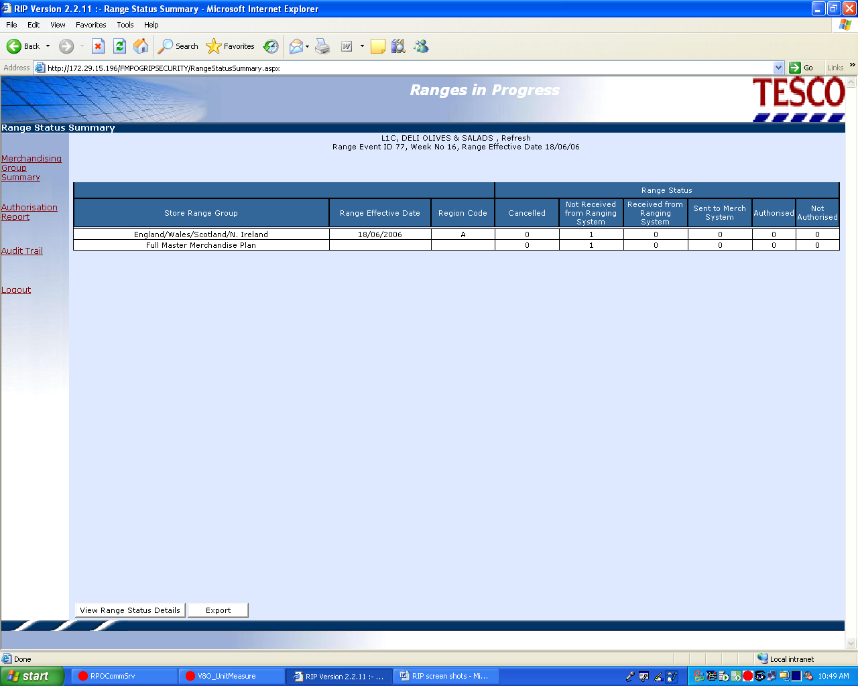

Changes Required
The changes required to the screen are as follows:
Item | As Is | To Be
Store Range Group Field | Store Range Group | Store Cluster
Region Code Field | Region Code (A, B, C, D…) | Remove from screen
Sent to Merch System Field | Sent to Merch System | Sent to Planogram System

Range Status Details
The user will then navigate to the Range Status Details screen to view the status of store clusters in more detail.
Promotional ranges and those for other non-ranged Display Groups will show as ‘Not Received’ from the Ranging system.
All error messages will be changed to be consistent with TOM terminology (see Requirements Catalogue at Section 3 for appropriate terms).

Screen Layout
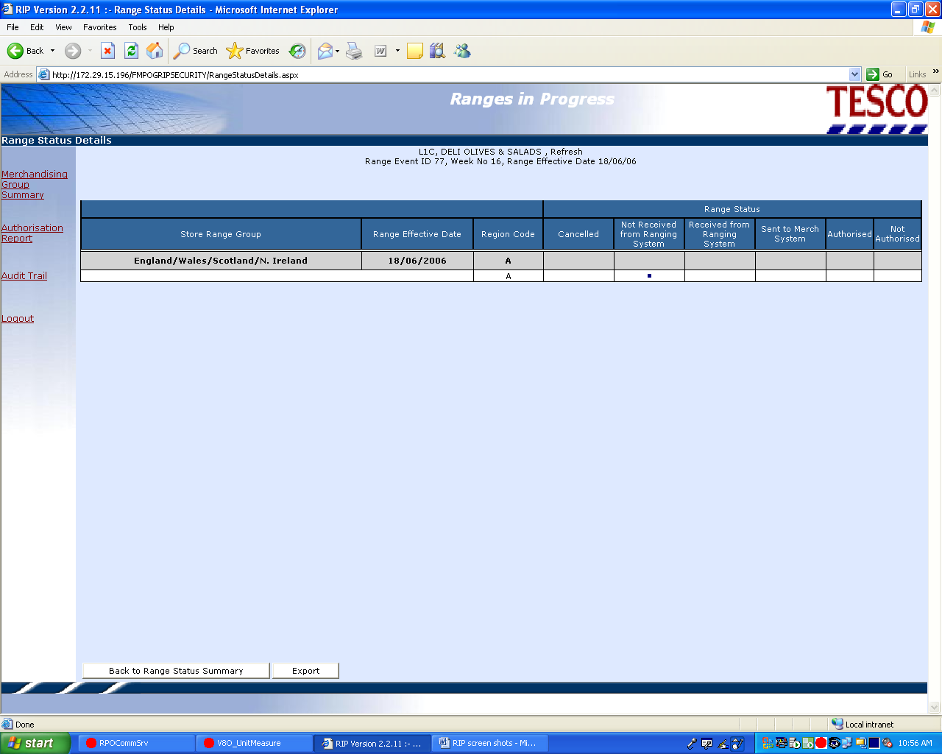

Changes Required
The changes required to the screen are as follows:

Item | As Is | To Be
Store Range Group Field | Store Range Group | Store Cluster
Region Code Field | Region Code (A, B, C, D…) | Remove from screen
Sent to Merch System Field | Sent to Merch System | Sent to Planogram System

Store Cluster Summary
The screen provides a summary of range information and indicates where ranges are expected. Also provides ranges to the planogram system for planning.
When user selects ‘Send Ranges to Display systems’, the system must check the status of the planogram in IKB.
Where the event ID cannot be found in planogram(s) in IKB, WIP planograms must be created based on event attributes and associated to the event ready to receive range-specific product records.
Where the event ID(s) match those found in one or more planograms in IKB, only the product pick-list needs to be updated.
Where the event ID(s) match those found in planogram(s) in IKB, system must check status of these planograms.
If there is not a corresponding WIP planogram then the range must not be sent. An error message must be displayed. The business process must then be for user to change status of the existing planogram to WIP.
If there is a corresponding WIP planogram then the range must be sent and update the product pick-list in the planogram system.
For a Display Group with ‘Ranges not ranged in the Ranging System’ indicator equal to ‘Y’, then user will not be able to send ranges to system, so the button must be disabled.
All error messages will be changed to be consistent with TOM terminology (see Requirements Catalogue at Section 3 for appropriate terms).

Screen layout
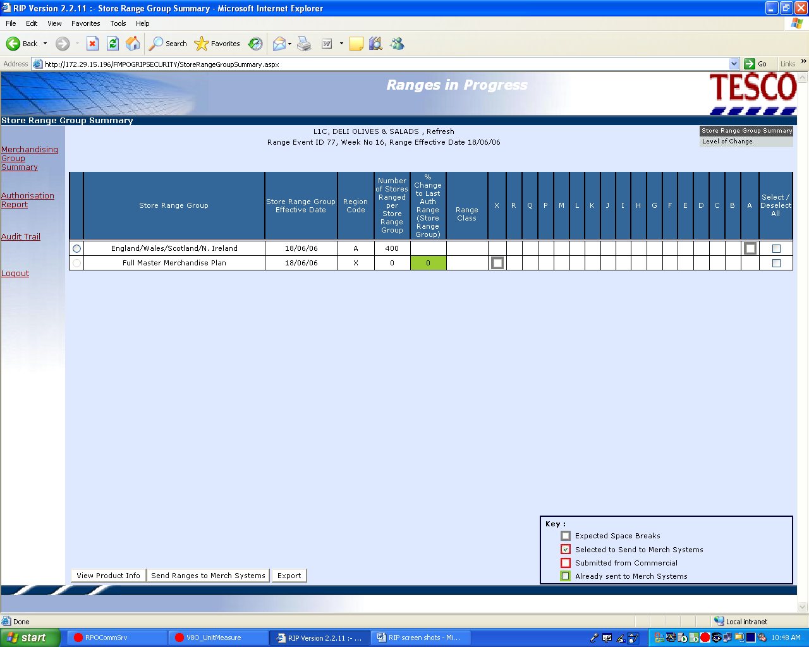

Changes Required
The changes required to the screen are as follows:

Item | As Is | To Be
Store Range Group Summary title field | Store Range Group Summary | Store Cluster Summary
Store Range Group field | Store Range Group | Store Cluster
Store Range Group Effective Date field | Store Range group Effective Date | Store Cluster Effective Date
Region Code Field | Region Code (A, B, C…) | Remove from screen
Number of Stores Ranged per Store Range Group field | Number of Stores Ranged per Store Range Group | Number of Stores Ranged per Store Cluster
% Change to last Authorised Range (Store Range Group) field | % Change to last Authorised Range (Store Range Group) | % Change to last Authorised Range (Store Cluster)
Send Ranges to Merch systems tab | Send Ranges to Merch systems | Send Ranges to Planogram systems
Key: Expected Space Breaks | Expected Space Breaks | Expected Range Classes
Key: Selected to Send to Merch systems | Selected to Send to Merch systems | Selected to Send to Planogram Systems
Key: Already Sent to Merch systems | Already Sent to Merch systems | Already Sent to Planogram Systems

Level of Change
The purpose of this screen is to show, as a percentage, the extent to which a range has changed at individual Range Class level.
All error messages will be changed to be consistent with TOM terminology (see Requirements Catalogue at Section 3 for appropriate terms).

Screen layout

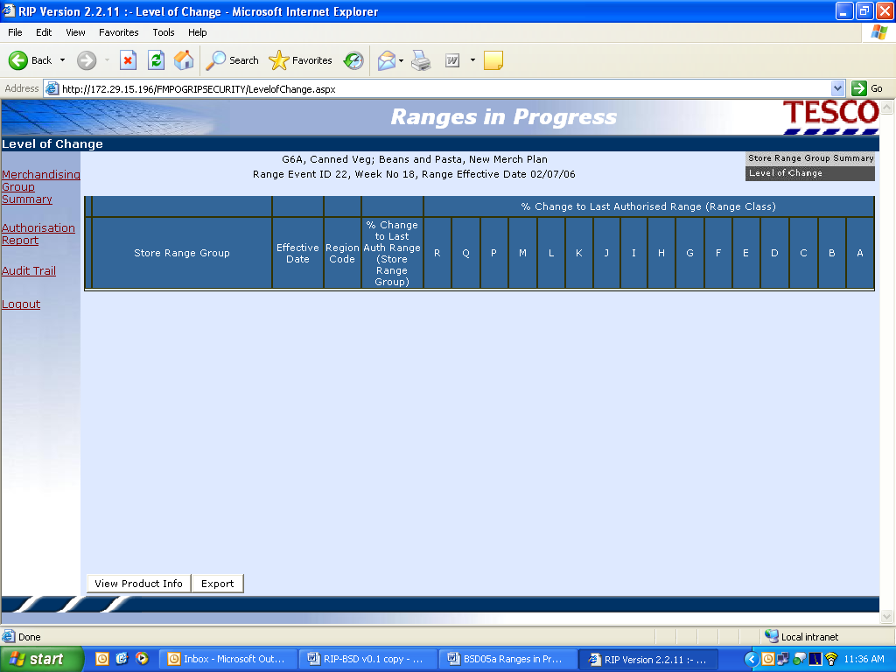

Changes Required
The changes required to the screen are as follows:

Item | As Is | To Be
Store Range Group Field | Store Range Group | Store Cluster
Region Code Field | Region Code (A, B, C…) | Remove from screen
% Change to last Authorised Range (Store Range Group) field | %Change To last Authorised Range (Store Range Group) | % Change To last Authorised Range (Store Cluster)

Product Summary
The purpose of this screen is to display a summary of information for the selected store cluster to enable the Merchandiser to assess the level of work required to merchandise the store cluster.
For promotions and other non-ranged events, only the first two lines of the product summary will contain values, as there will be no range information from the Ranging System. Also, for TOM Version 1 there will be no overlays for an event.
All error messages will be changed to be consistent with TOM terminology (see Requirements Catalogue at Section 3 for appropriate terms).

Screen layout
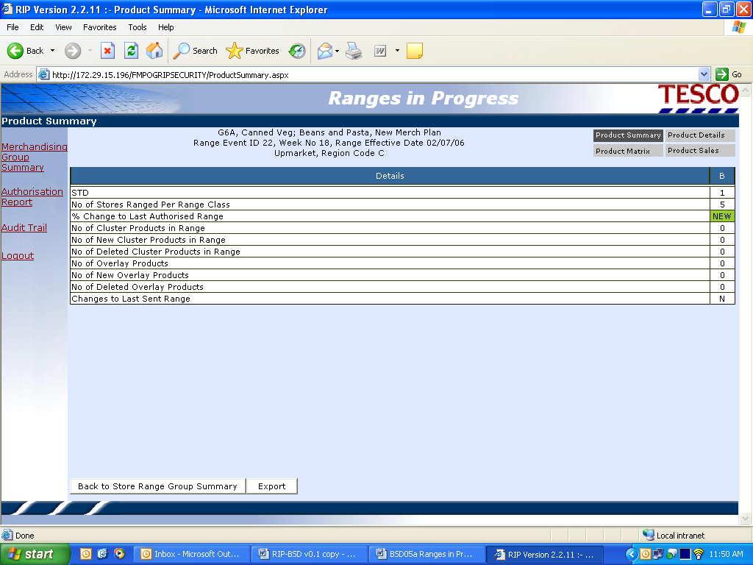

Changes Required
The changes required to the screen are as follows:

Item | As Is | To Be
Cluster details in header | Cluster description, Region Code | Remove Region Code
Cluster Products summary lines | No. of cluster products in range, No. of new cluster products in range, No. of deleted cluster products in range | Will always be zero for Promotional and other non-ranged events
Overlays summary lines | No. of Overlay products, No. of New overlay products and No. of deleted Overlay products | Will always be zero for TOM version 1
Back to Store Range Group Summary Tab | Back to Store Range Group Summary | Back to Store Cluster Summary

Product Details
The purpose of this screen is to display a list of products for the selected store cluster and summarise where they have been ranged, indicating whether they are new, deleted, discontinued, extended, reduced or overlay products.
No information will be seen for promotional/non-ranged display groups.
All error messages will be changed to be consistent with TOM terminology (see Requirements Catalogue at Section 3 for appropriate terms).

Screen layout

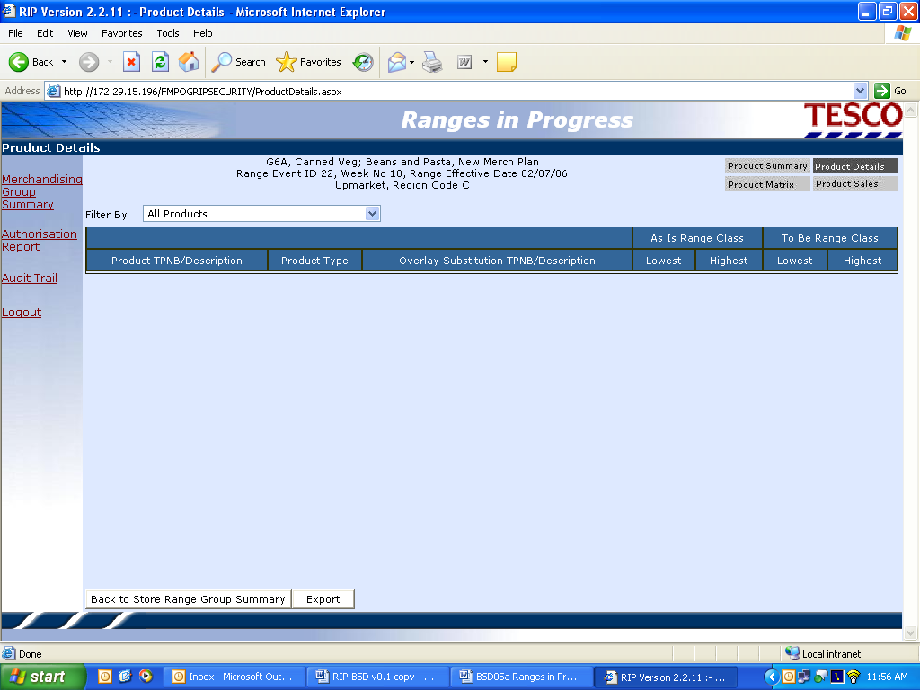

Changes Required
The changes required to the screen are as follows:

Item | As Is | To Be
Cluster details in header | Cluster description, Region Code | Remove Region Code
Product TPNB/Description Field | Product TPNB/Description | Product ID/Description
Overlay Substitution TPNB/Description Field | Overlay Substitution TPNB/Description | Overlay Substitution Product ID/Description
Back to Store Range Group Summary Tab | Back to Store Range Group Summary | Back To Store Cluster Summary

Product Matrix
The purpose of this screen is to display a list of products for the selected store cluster and show where they have been ranged, indicating whether they are new, deleted, extended, reduced or overlay products.
No information would be seen for promotional/non-ranged display groups.
All error messages will be changed to be consistent with TOM terminology (see Requirements Catalogue at Section 3 for appropriate terms).

Screen Layout
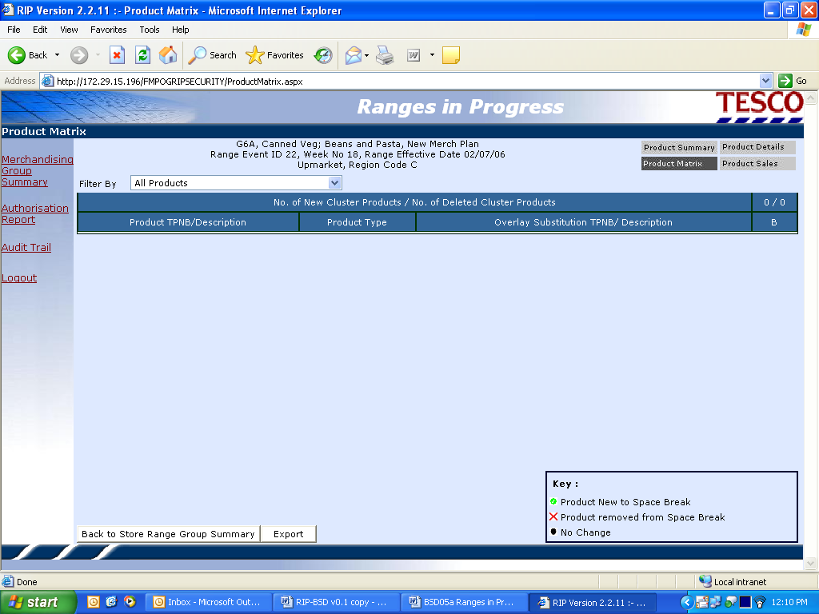

Changes Required
The changes required to the screen are as follows:

Item | As Is | To Be
Cluster details in header | Cluster description, Region Code | Remove Region Code
Product TPNB/Description Field | Product TPNB/Description | Product ID/Description
Overlay Substitution TPNB/Description Field | Overlay Substitution TPNB/Description | Overlay Substitution Product ID/Description
Back to Store Range Group Summary Tab | Back to Store Range Group Summary | Back To Store Cluster Summary
Key | Product New to Space Break  Product Removed from Space Break | Product New to Range Class  Product Removed from Range Class

Product Sales
The purpose of this screen is to view the system generated To Be Sales and Commercial Forecast Sales by range class for each product in the selected store cluster.
No information would be seen for promotional/non-ranged display groups.
All error messages will be changed to be consistent with TOM terminology (see Requirements Catalogue at Section 3 for appropriate terms).

Screen Layout
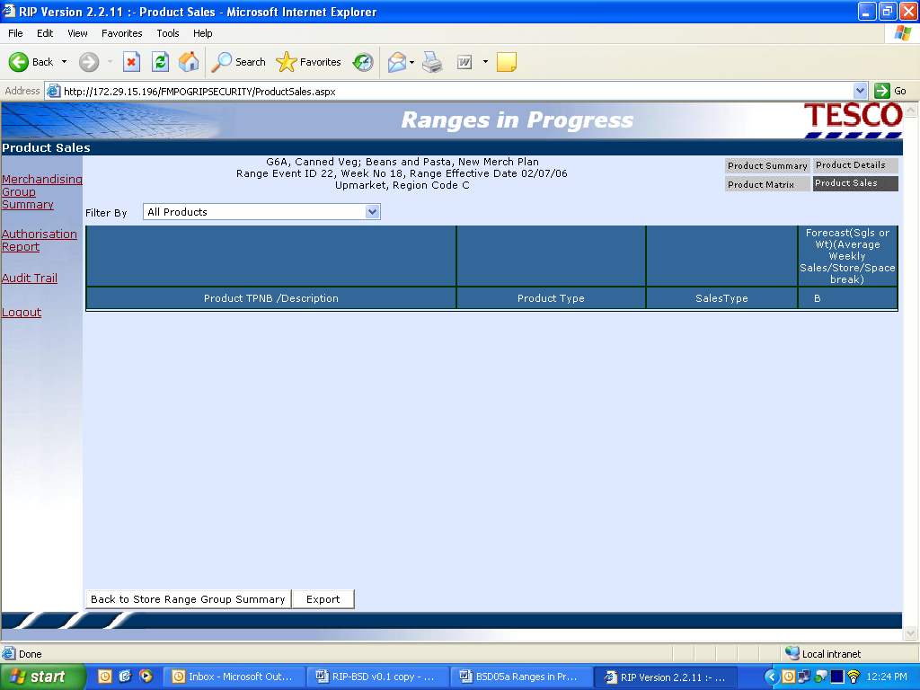

Changes Required
The changes required to the screen are as follows:

Item | As Is | To Be
Cluster details in header | Cluster description, Region Code | Remove Region Code
Product TPNB/Description Field | Product TPNB/Description | Product ID/Description
Forecast column header | (Average weekly sales/store/space break) | (Average weekly sales/store/range class)
Back to Store Range Group Summary Tab | Back to Store Range Group Summary | Back To Store Cluster Summary

Reconcile Store Clusters
Once ranges have been planned in the planogram system, the process of reconciliation within Ranges in Progress will identify any issues that will prevent ranges from being authorised.
Promotional/non-ranged Range Events will appear on this screen as ‘Range received from ranging system’, although this is not really the case. This will enable the user to select the store clusters for reconciliation.
For non-ranged Display Groups only the following validation will be performed:
- dummy product and description present
- products contained in a plan that are currently unauthorised
- products in a plan that do not meet level run down criteria in the Planogram System
- where an inappropriate sales history period has been used
The full validation will be performed for all other types of Display Group.
Reconciliation will be requested at store cluster level and will occur for every supported range class within the clusters selected.
For each range to be reconciled, the system will compare the products in the range with the products placed on the corresponding Work in Progress (WIP) planograms.
The range and plan will be matched on the following:
- Range Event ID
- Display Group Code
- Store Cluster Description
- Range Class
- Planogram Name
- Product ID
- Warning
- Level Rundown error
- Store Cluster ID
- DbKey – used internally to identify different Planograms for the same product and store

If more than one plan exists for a single range (because of different equipment types) all plans will be compared to the single range and the errors attributed to the corresponding plan.
All error messages will be changed to be consistent with TOM terminology (see Requirements Catalogue at Section 3 for appropriate terms).

Screen Layout
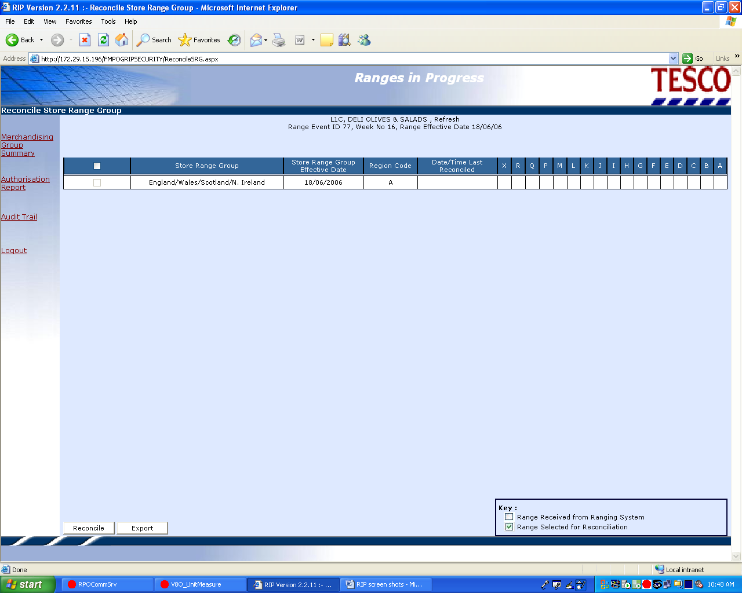

Changes Required
The changes required to the screen are as follows:

Item | As Is | To Be
Store Range Group field | Store Range Group | Store Cluster
Store Range Group Effective Date Field | Store Range Group Effective Date | Store Cluster Effective Date
Region Code Field | Region Code (A, B, C…) | Remove from screen
Supported Range Classes | X followed by Z to A | X followed by A to Z

Reconciliation Errors
The following screens show the results of the reconciliation:
- Reconciliation Errors Summary
- Reconciliation Errors by Display Group
- Reconciliation Errors by Level of Change
- Reconciliation Errors by Planogram
- Reconciliation Errors by Product
Range Events for non-ranged Display Groups will not have reconciliation errors.
All error messages will be changed to be consistent with TOM terminology (see Requirements Catalogue at Section 3 for appropriate terms).

Screen Layout
Screen shots are not available for the above screens.

Changes Required
The changes required to the screens are as follows:

Reconciliation Errors Summary
Item | As Is | To Be
Button | Errors by Merch Plan | Errors by Planogram
Button | Errors by Merch Group | Errors by Display Group
Button | Back to Reconcile Store Range Group | Back to Reconcile Store Cluster
Store Range Group field | Store Range Group | Store Cluster
Supported Range Classes | X followed by Z to A | X followed by A to Z
FMPOG description | Full Master Merchandise Plan | Full Master Planogram

Reconciliation Errors by Display Group
Item | As Is | To Be
Screen title | Reconciliation Errors by Merch Group | Reconciliation Errors by Display Group
Button | Errors by Merch Plan | Errors by Planogram
Button | Errors by Merch Group | Errors by Display Group
Button | Back to Reconcile Store Range Group | Back to Reconcile Store Cluster

Reconciliation Errors by Level of Change
Item | As Is | To Be
Screen title | Reconcile by Level of Change | Reconciliation Errors by Level of Change
Button | Errors by Merch Plan | Errors by Planogram
Button | Errors by Merch Group | Errors by Display Group
Button | Back to Reconcile Store Range Group | Back to Reconcile Store Cluster
Store Range Group field | Store Range Group | Store Cluster
Supported Range Classes | X followed by Z to A | X followed by A to Z

Reconciliation Errors by Planogram
Item | As Is | To Be
Screen title | Reconciliation Errors by Merch Plan | Reconciliation Errors by Planogram
Button | Errors by Merch Plan | Errors by Planogram
Button | Errors by Merch Group | Errors by Display Group
Button | Back to Reconcile Store Range Group | Back to Reconcile Store Cluster
FMPOG description | Full Master Merchandise Plan | Full Master Planogram

Reconciliation Errors by Product
Item | As Is | To Be
Button | Errors by Merch Plan | Errors by Planogram
Button | Errors by Merch Group | Errors by Display Group
Button | Back to Reconcile Store Range Group | Back to Reconcile Store Cluster
Column header | Sub Group | Sub Class
Column header | Merch Plan Range Class | Planogram Range Class

Authorise Store Clusters
When the Display Team are satisfied that ranges and planograms meet all the business rules and that they are satisfactorily reconciled, they will authorise ranges in Ranges in Progress. Only after this has occurred can the range be made available to downstream systems for implementation in stores.
The process is the same for non-ranged Display Groups. These will appear in the list even though no ranges have been physically received from the Ranging System.
The user selects the store clusters to be authorised and when the Authorise button is pressed a final reconciliation is triggered.
All error messages will be changed to be consistent with TOM terminology (see Requirements Catalogue at Section 3 for appropriate terms).

Screen layout
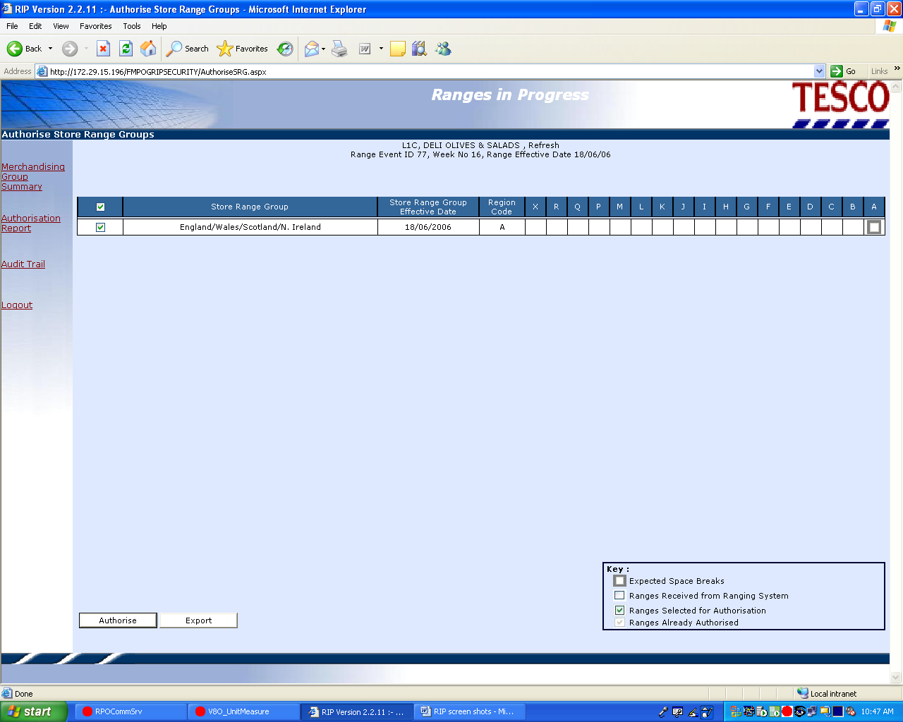

Changes Required
The changes required to the screen are as follows:

Item | As Is | To Be
Store Range Group field | Store Range Group | Store Cluster
Store Range Group Effective Date Field | Store Range Group Effective Date | Store Cluster Effective Date
Region Code Field | Region Code (A, B, C…) | Remove from screen
Supported Range Classes | X followed by Z to A | X followed by A to Z
Key | Expected Space Breaks | Expected Range Classes
FMPOG description | Full Master Merchandise Plan | Full Master Planogram

Authorise Ranges
When the final reconciliation has completed successfully the user selects the ranges to be authorised using this screen.

Screen layout
A screen shot is not available for the above screen.

Changes Required
The changes required to the screen are as follows:

Item | As Is | To Be
Store Range Group field | Store Range Group | Store Cluster
Store Range Group Effective Date Field | Store Range Group Effective Date | Store Cluster Effective Date
Supported Range Classes | X followed by Z to A | X followed by A to Z
FMPOG description | Full Master Merchandise Plan | Full Master Planogram
Key | Expected Space Breaks | Expected Range Classes

Authorisation Report Selection
The user can select the Authorisation Report to be viewed.
All error messages will be changed to be consistent with TOM terminology (see Requirements Catalogue at Section 3 for appropriate terms).

Screen Layout
Screen shots are not available for the above screens.

Changes Required
The changes required to the screens are as follows:
Item | As Is | To Be
Select Merch Group Code | Select Merch Group Code | Select Display Group Code

Authorisation Report
This report will provide a view of any reconciliation errors identified at the point of range authorisation for selected store clusters.
There will be no reconciliation errors for non-ranged display groups as the planogram will be reconciled against itself, so it will always be successful.
For ranged display groups, the errors and their treatment is as follows:
Reconciliation Errors that may be accepted:
- Products with Warnings
- Products on plan not in range
- Products in range not on plan
- Level Rundown Failures
- Level of Change
The following errors may not be accepted, and further actions will be needed to rectify them:
- Dummy New Products on plan
- Dummy New Products in range
- Unauthorised products in range
- Ranges Not Received from Ranging System
- Sales History Agreed flag still set to N
All error messages will be changed to be consistent with TOM terminology (see Requirements Catalogue at Section 3 for appropriate terms).

Screen Layout
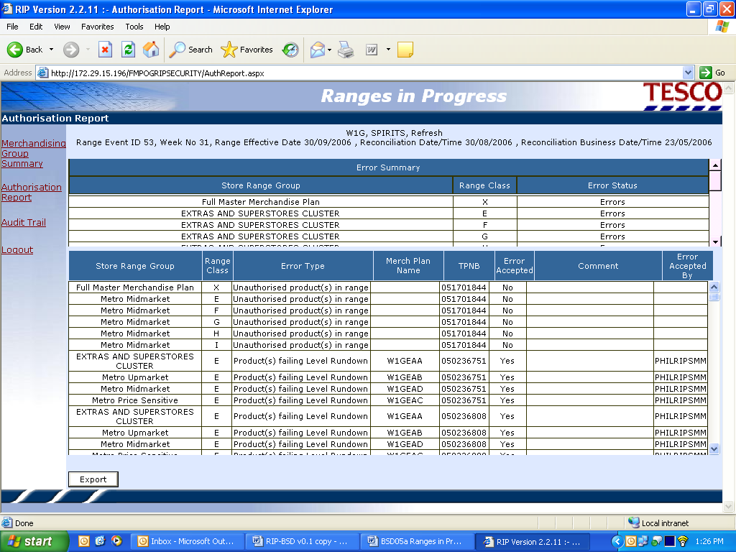

Changes Required
The changes required to the screen are as follows:
Item | As Is | To Be
Error Summary Store Range Group field | Store Range Group | Store Cluster
Error Summary FMPOG description | Full Master Merchandise Plan | Full Master Planogram
Error Detail Store Range Group field | Store Range Group | Store Cluster
Merch Plan Name field | Merch Plan Name | Planogram Name
TPNB Field | TPNB | Product ID
Error Detail FMPOG description | Full Master Merchandise Plan | Full Master Planogram

Audit Trail
The audit trail logs the number of times a range has been “sent” or “submitted for authorisation” from the Ranging system to Ranges in Progress and when a range was authorised and by whom.
Non-ranged Display Groups will never be sent or submitted from the Ranging System, but they will be authorised in RIP.
All error messages will be changed to be consistent with TOM terminology (see Requirements Catalogue at Section 3 for appropriate terms).

Screen layout
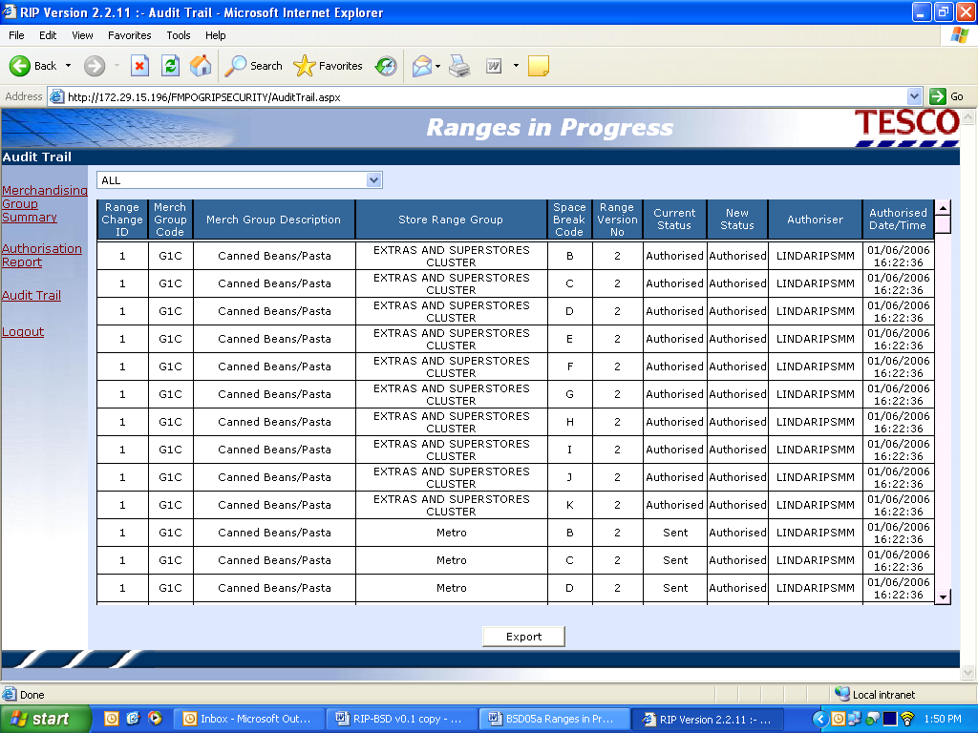

Changes Required
The changes required to the screen are as follows:

Item | As Is | To Be
Merch Group Code field | Merch Group Code | Display Group Code
Merch Group Description field | Merch Group Description | Display Group Description
Store Range Group Field | Store Range Group | Store Cluster
Space Break Code Field | Space Break Code | Range Class

Integration
- Store Clustering, Display Group Management and Schedule share the commercial range database therefore do not need a direct interface with Ranges In Progress.
- Ranges in Progress reads IKB, either through the Integration layer or directly (await decision and clarity on the same) to get planogram data for reconciliation, and can also read IKB to check planogram status
- Range information for non-ranged display groups (e.g. promotional display groups) must pass from IKB to Store Range once the ranges have been authorised in Ranges in Progress.

Existing interfaces to be used as is
- S052 New and Approved Base Products (UK47 Placeholder Linking)
- S052.5 Dummy Base Products (UK48 Placeholder Link Info)
- S007 Cluster Ranges (proposed) (UK33 Commercial Range)
- S006 Overlays (planned) (UK49 Commercial Overlays)
- S066 Range Class Controls (UK117 Space Break Control Info)

Existing interfaces to be changed
- S001 Cluster Ranges (proposed) with historical sales (UK34 CRST Range)
Add Equipment Type, Space Break (no of mods), change existing ‘Space Break’ to ‘Range Class’
- S022 Event Schedule (UK141 SRM Schedule ProSpace)
Add Range Event End Date (will not be populated in Version 1), Range Status (01=In Progress, 02= Authorised, 03=Live)

New interfaces
None

Existing Interfaces not required for TOM
- UK82 Range Status
- UK79 MG in Store Region Code

Requirements Catalogue
Requirement Id | Description | Priority
1.000 | All Languages and terminologies must be translatable to different languages
1.001 | Translate the system configuration into different languages | S
1.002 | Translate the system client into different languages | S
1.003 | Translate systems messages into different languages | S
2.000 | Change all terminology to operating model standards
2.001 | Change all references to merchandising group to display group | M
2.002 | Change all references of merchandising group code to display group code | M
2.003 | Change all references of store range group to store cluster | M
2.004 | Change all references of sub-group to sub-class | M
2.005 | Change all references of forecast(Sgls or Wt) to weekly sales forecast | S
2.006 | Change all references of TPNB to Product Number | M
2.007 | Ensure all references to ‘type of range change’ relate to terminology used within the SRD Schedule, e.g Major, Minor and out-of-cycle. Controlled by the values set up in ranging controls parameters | M
2.008 | Remove Tesco week number | W
2.009 | Change space break code to range class | M
2.010 | Change merch plan name to planogram name | M
3.000 | Replace UK specific functionality
3.001 | Remove References to region code | M
3.002 | Ensure that level of change parameters are variable by country | S
4.000 | Enhancements
4.001 | Where cluster description is shown, add cluster code in adjacent column
4.002 | Sub-class code to be shown next to sub-class description | S
4.003 | Add cluster description in the reconciliation errors by merch group screens | S
4.004 | Add to error report ‘attempting reconciliation in wrong status’. Need to validate that reconciliation is only being attempted when the planogram is at status ASO | S
4.005 | Add another column for ‘range classes’, rather then grouping under cluster code | C
4.006 | Relocate drop down menus from top right of screen to bottom of screen page, consistent with rest of drop down screens | C
4.007 | Ensure range classes are located close to product summary details rather than spanned across page, for ease of read | C
4.008 | Ensure equipment details are shown by their full description as well as shown in code. Equipment details to be consistent with planogram naming convention and be consistent with planogram system/floor planning system | S
5.000 | Ensure current UK change control on re-format screens has been implemented | S
5.001 | Separate columns for TPNB and product description | S
6.000 | Feeds of data required must be provided by TOM system architecture | M
7.000 | Ensure that promotional plans and ranges can be authorised | M
8.000 | Add overlays to reconciliation process | W
9.000 | Enable more than one plan to be reconciled to a single range | M

Screenshots showing system changes
These screenshots have been added for information. Please note that the system has not been system tested at this point.

Login Page

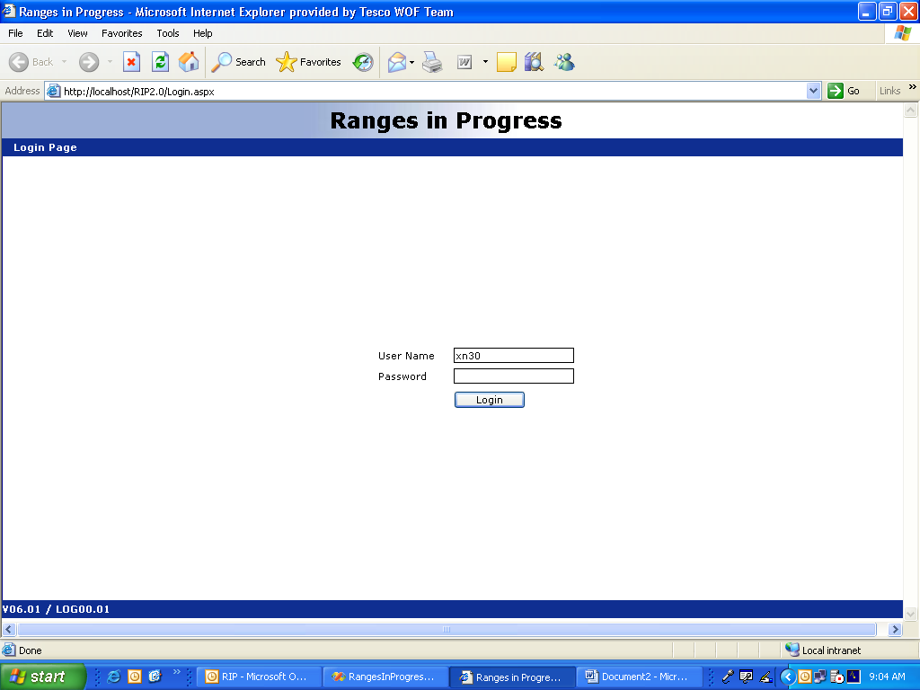
Select User

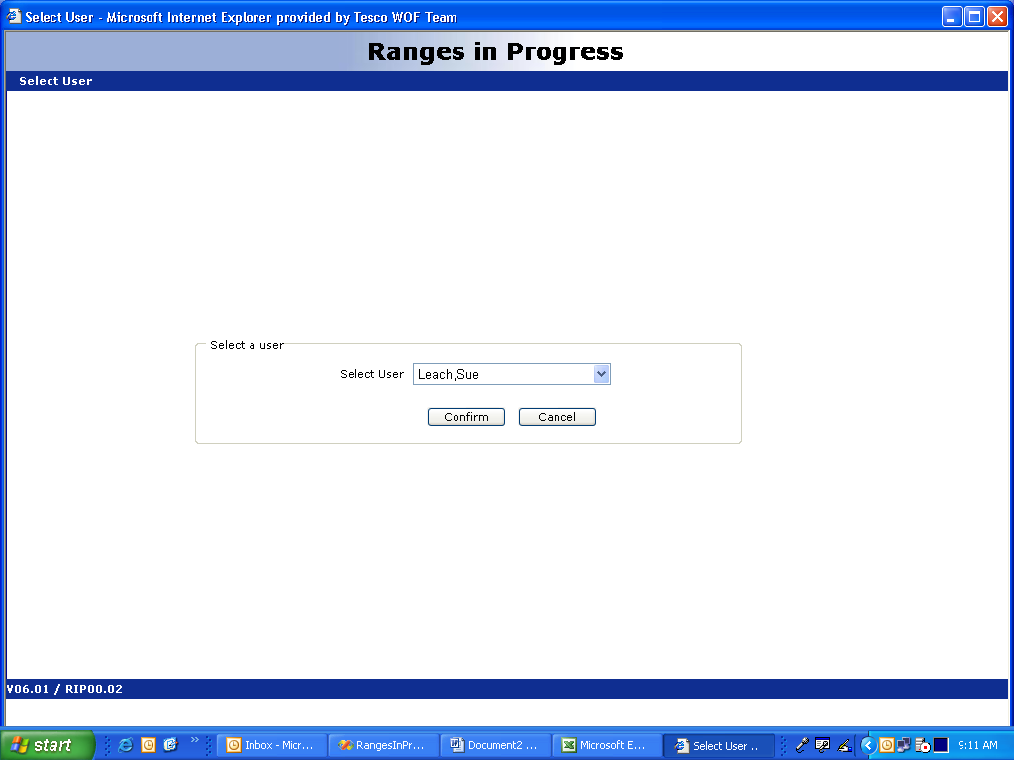

Display Group Summary

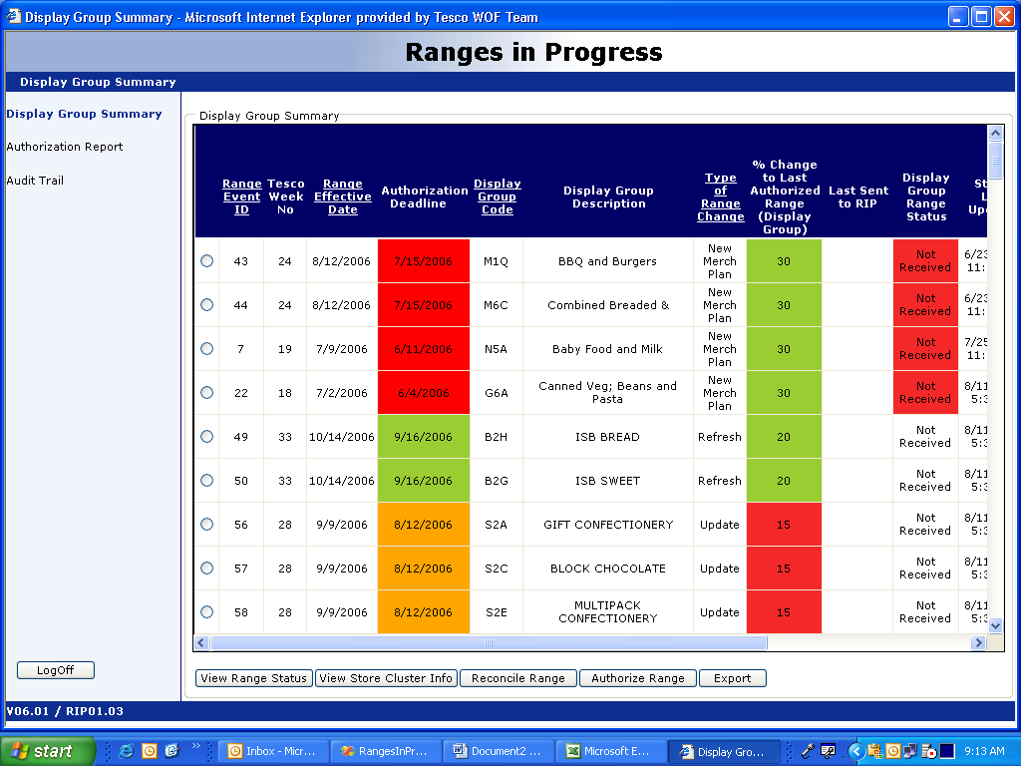

View Range Status Summary

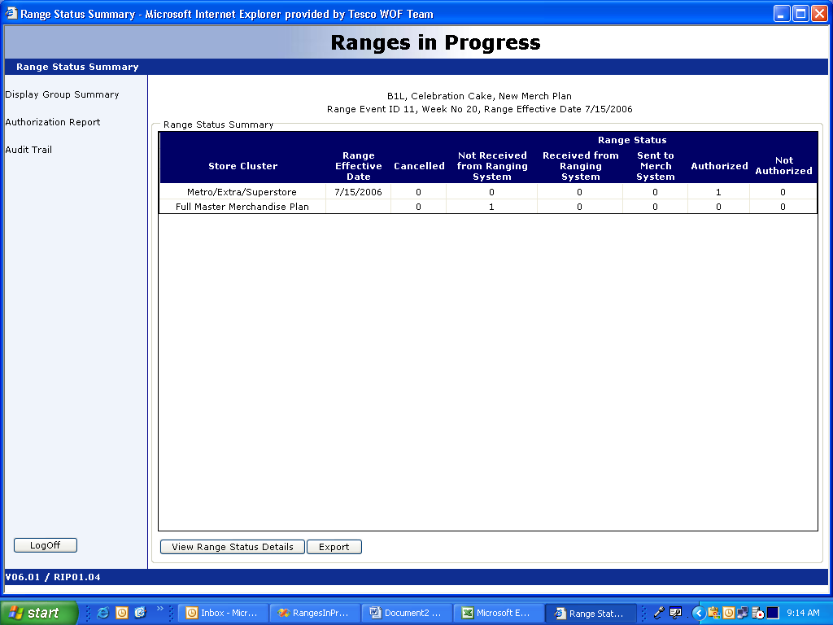

View Range Status Details

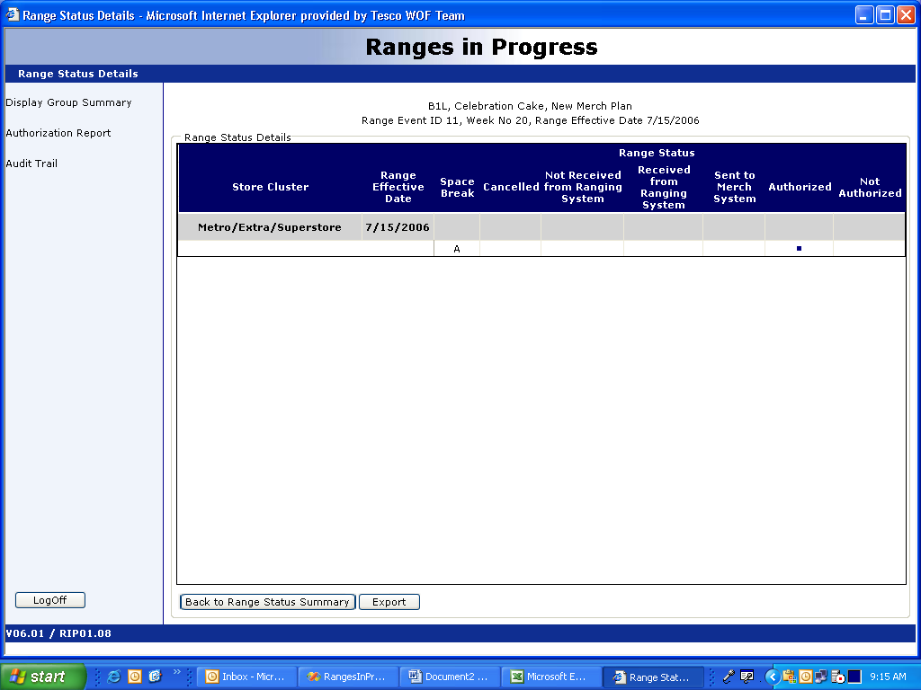

Store Cluster Summary

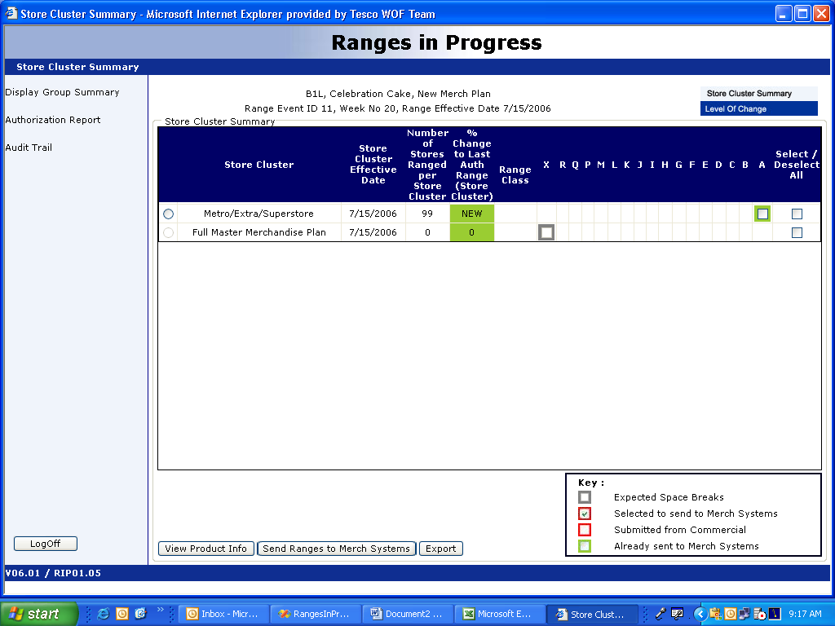

View Level of Change

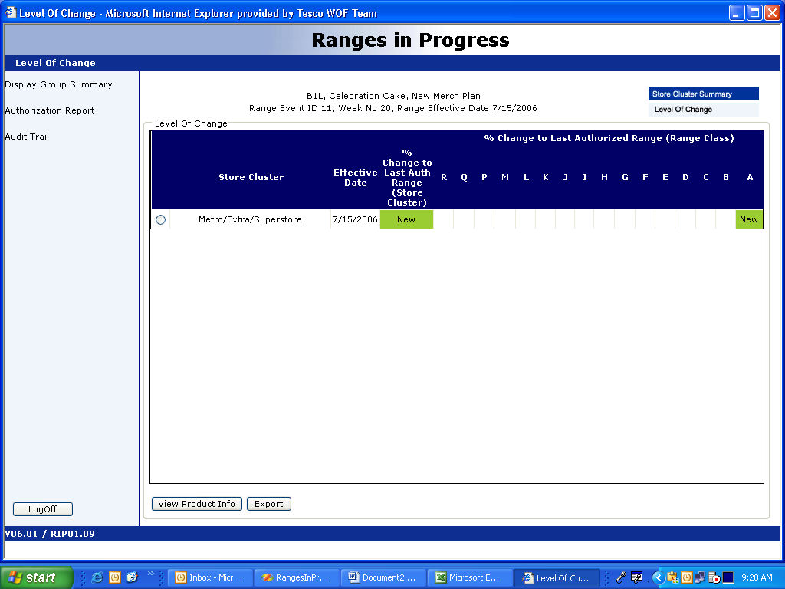

Reconciliation Errors Summary Page

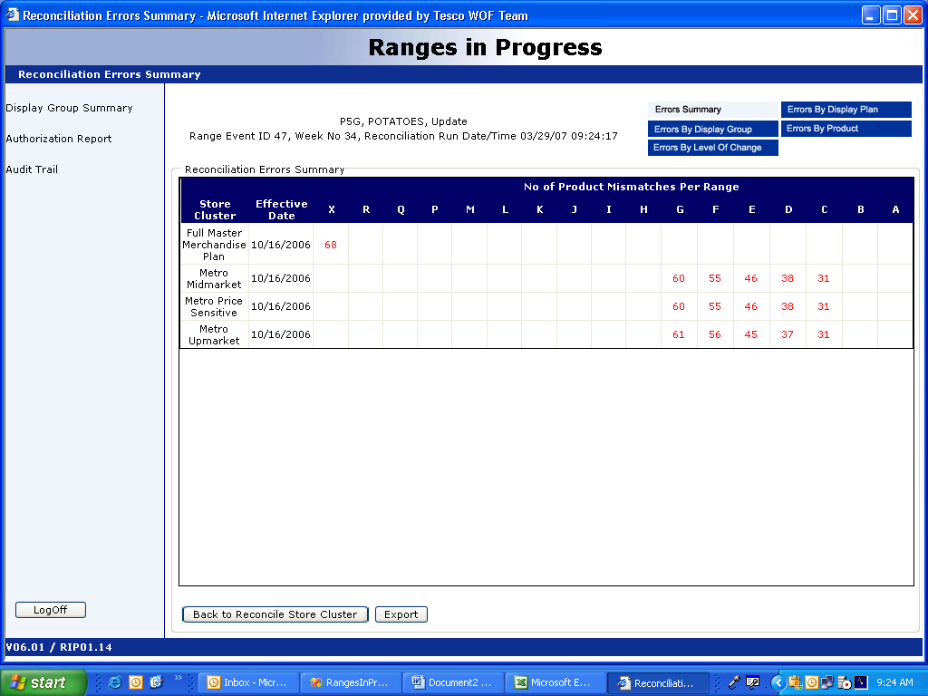

Reconciliation Errors by Display Group

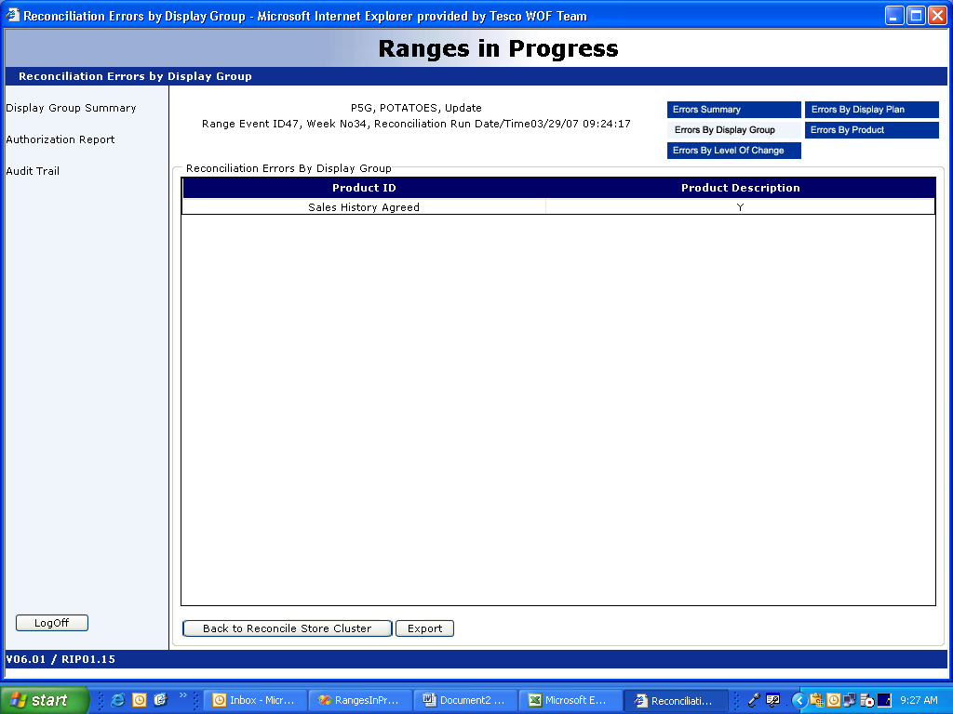

Reconciliation Errors by Level of Change

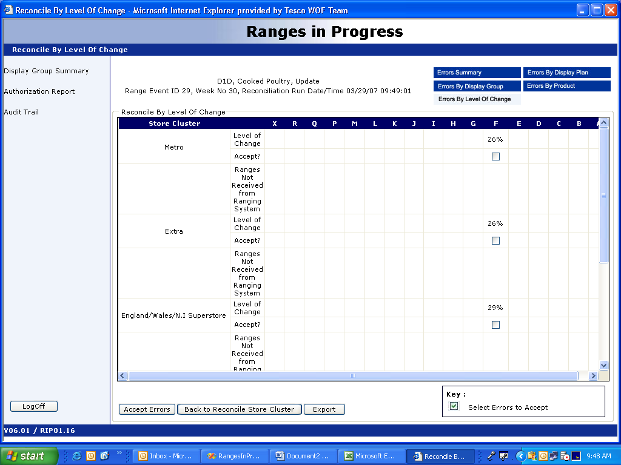

Reconciliation Errors by Display Plan

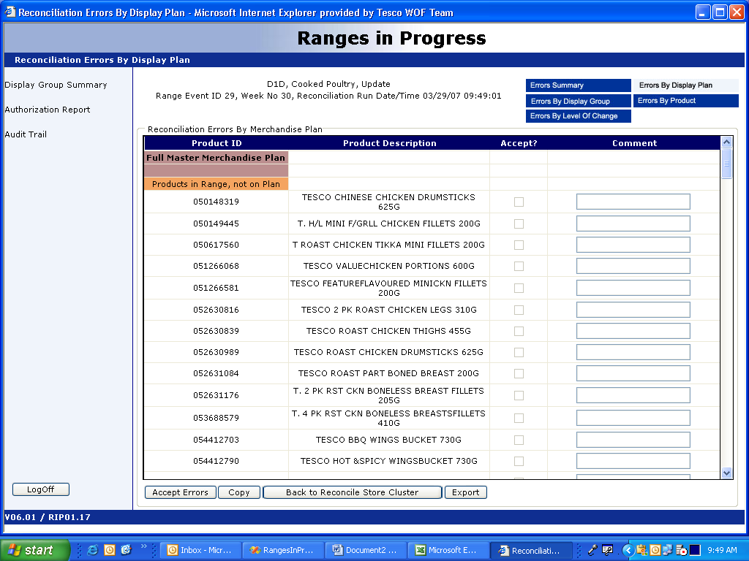
Reconciliation Errors by Product

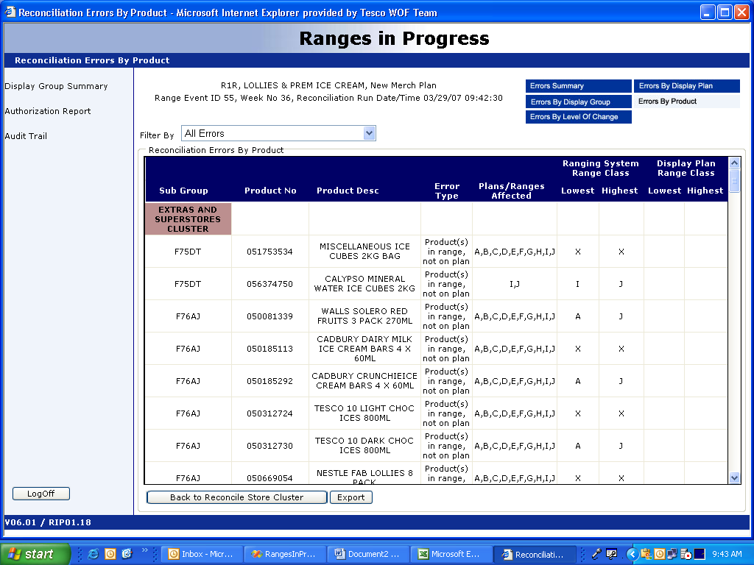

Authorize Store Clusters

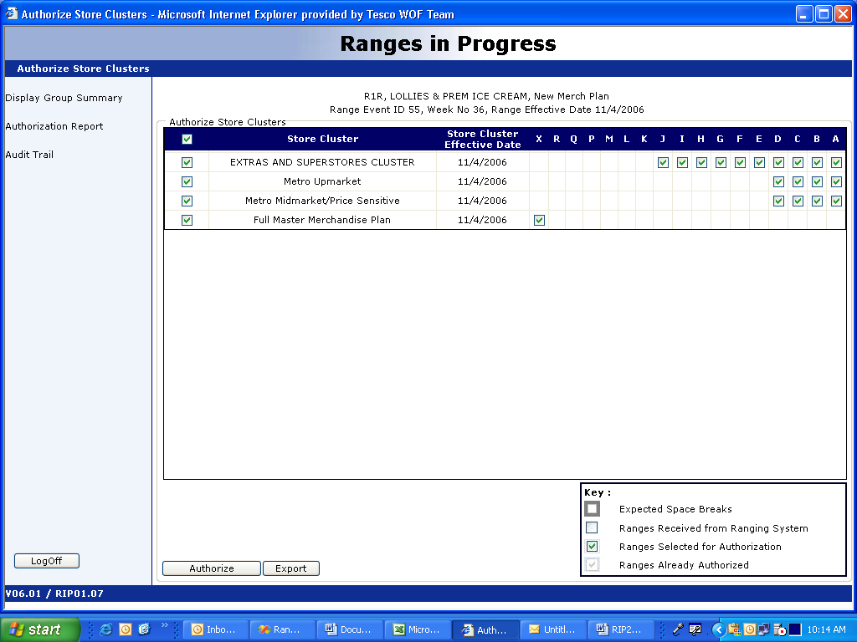

Authorize Ranges

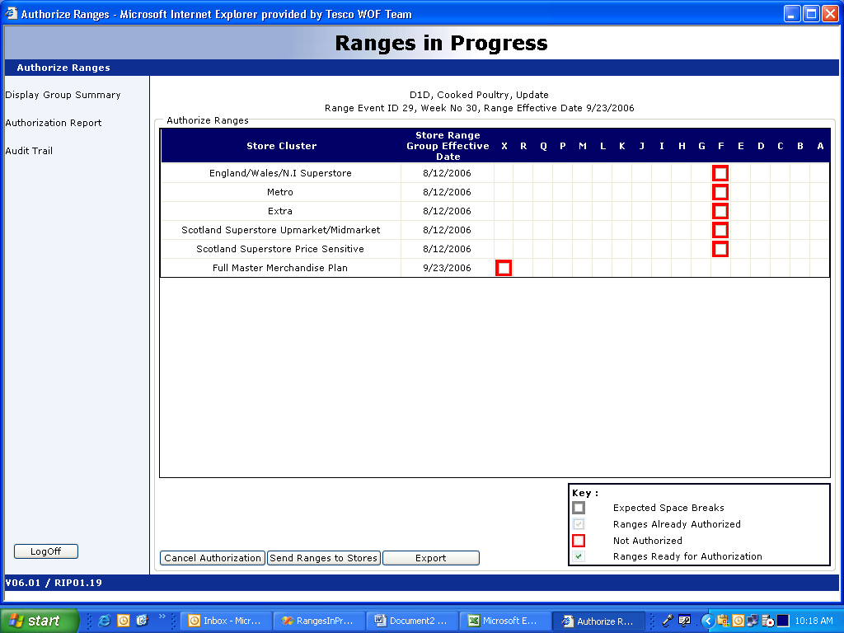

View Product Summary

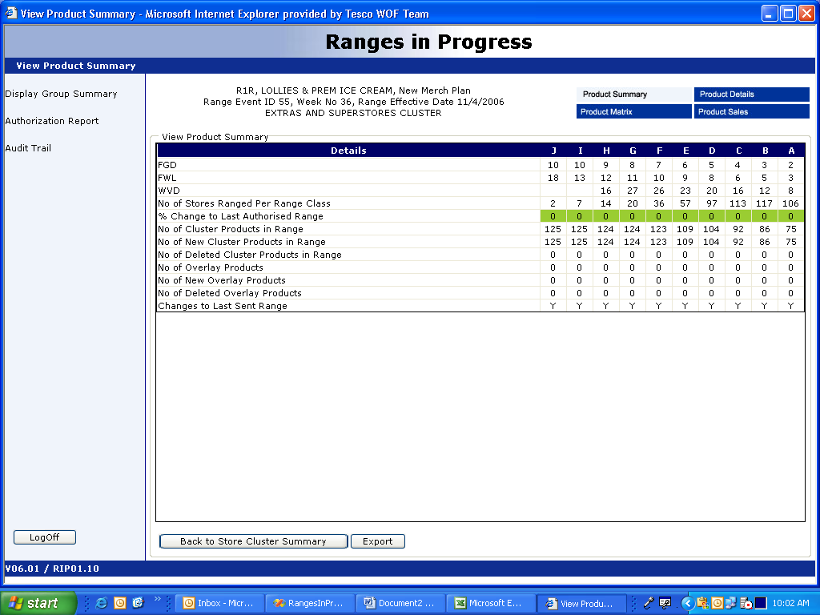

View Product Details

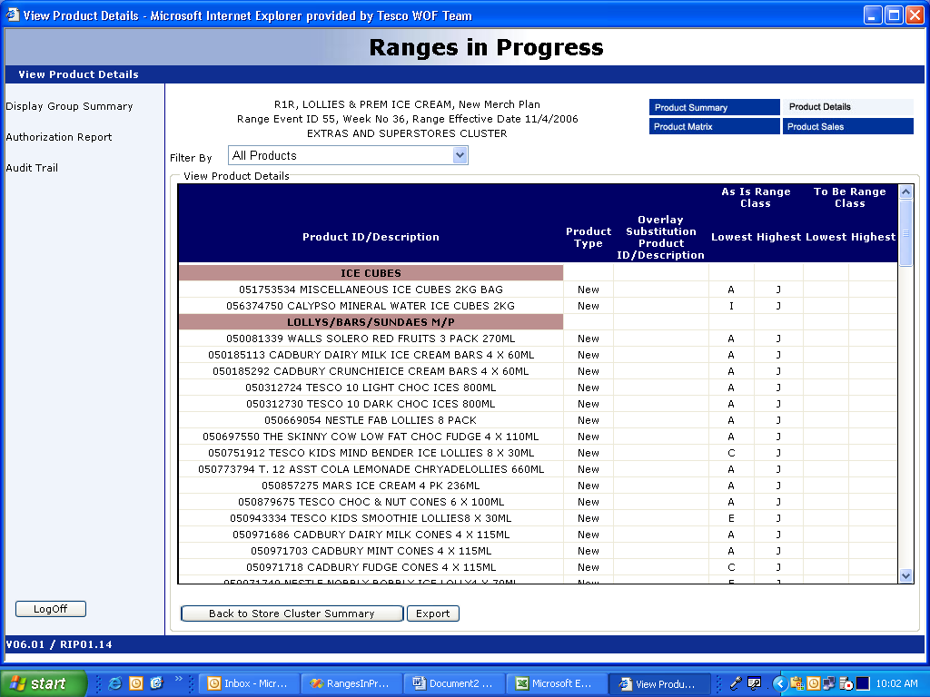

View Product Matrix

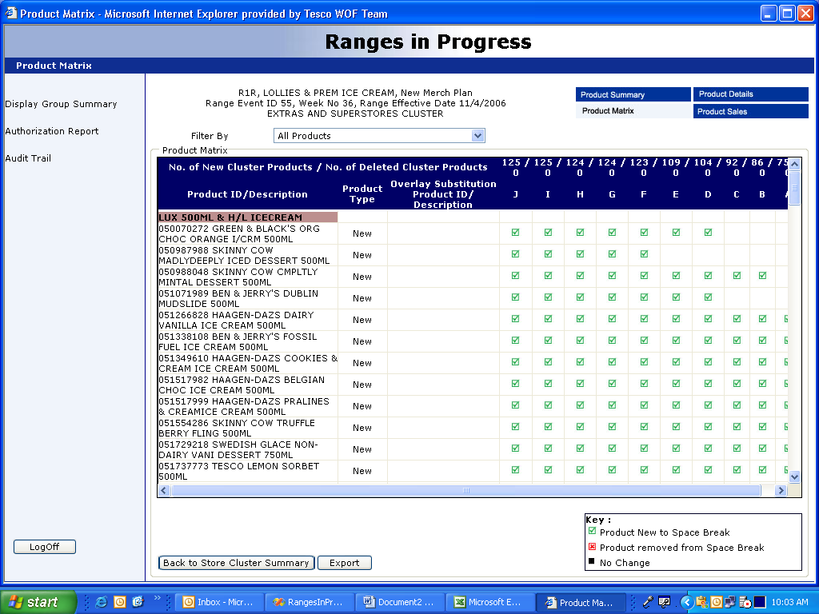

View Product Sales

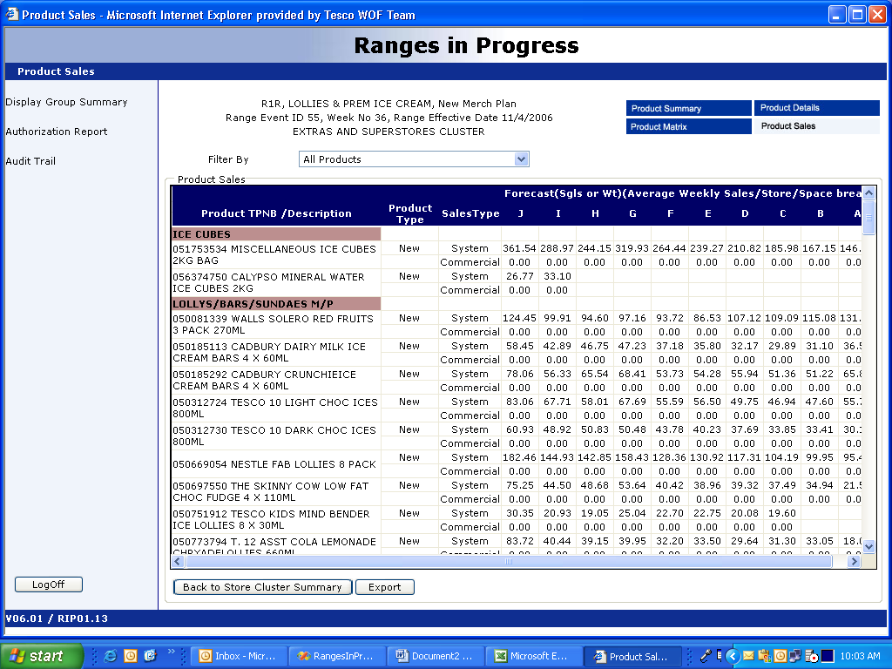

Management Information Reports (Authorization Report)

1. Authorization Report Selection

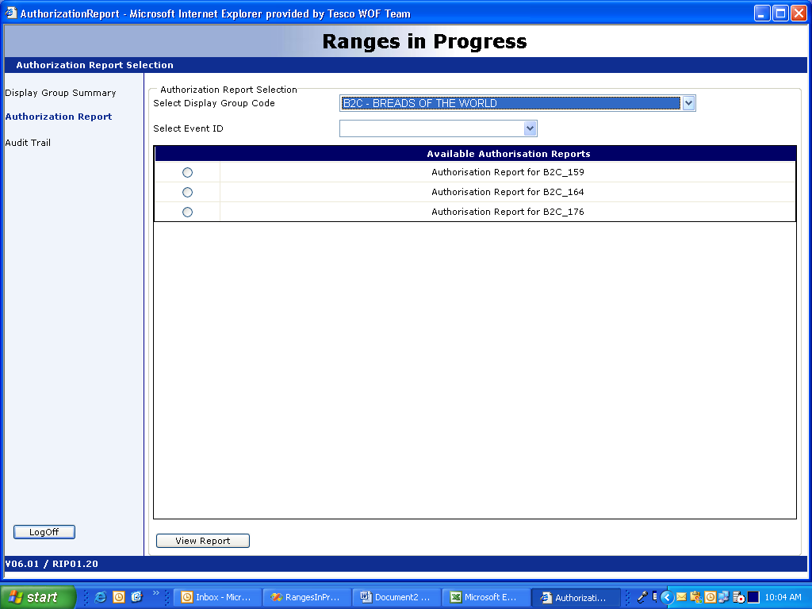

2. Authorization Report

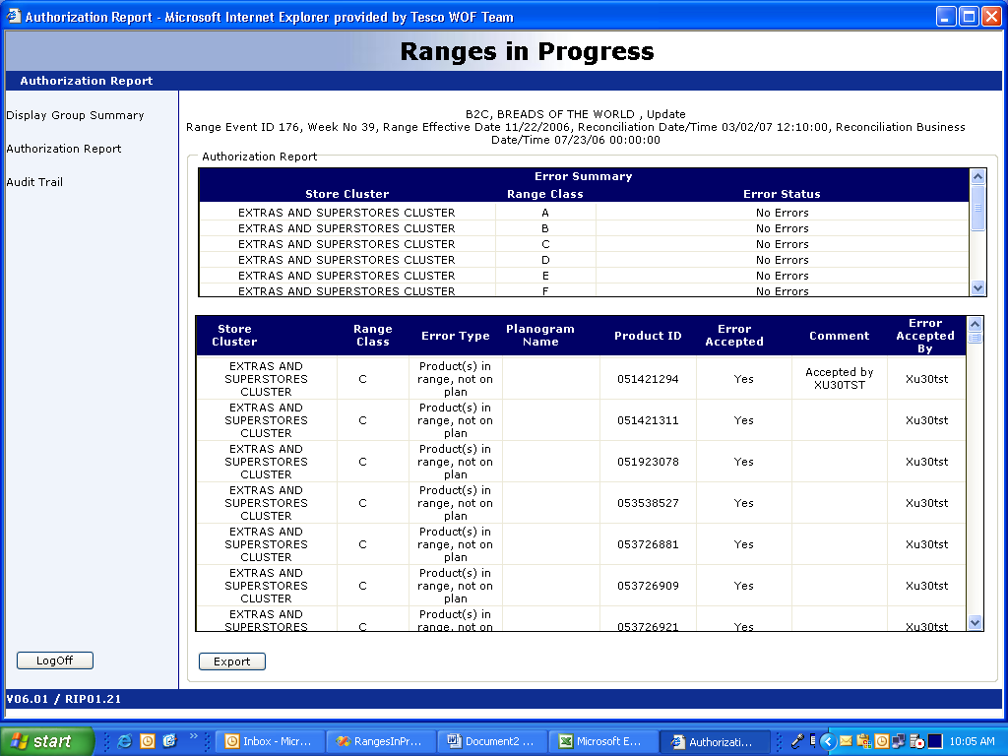

View Audit Trail

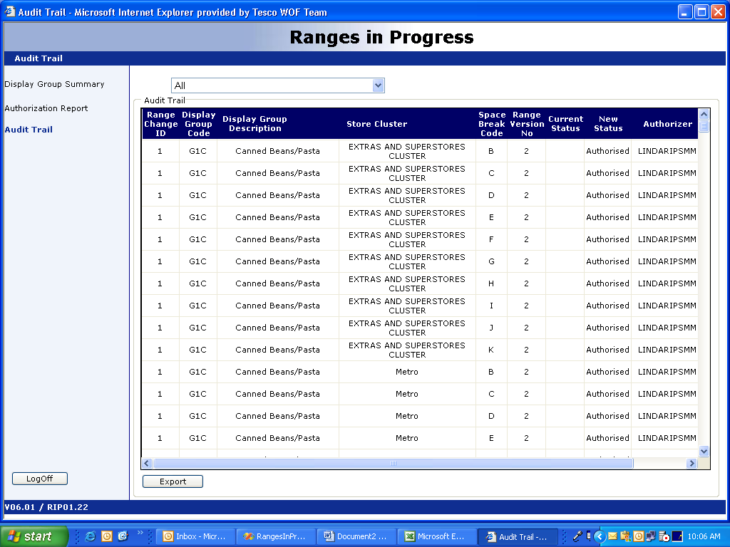

Document Control

Project: | TOM Space Range & Display version 1
Document Title: | BSD Ranges In Progress 0.4
Document Location: | Docshare\ Space Range & Display\ Ranges In Progress
Distribution: | Emma Kenyon  Amanda Sawkins  Mark Hillman | Samantha Baptiste  Anjali Khimasia  Eva Hotmarova  Rahul Bhandari  Srikanth Rangarajan  Senthilkumar Ganapathi

Change Record

Date | Author | Change Description | Version
24/01/2007 | Rakesh Roshan | Initial Draft | 0.1
30/01/07 | Rakesh Roshan | Changed Draft | 0.2
07/02/07 | Rakesh Roshan | Changes after review, ready for sign-off | 0.3
08/04/07 | Hilary Waterhouse | Changes for further review | 0.4
10/04/07 | Hilary Waterhouse | Added missing screen and detail of interfaces | 0.5

Associated Documents

Document Title: | Location:
Space, Range and Display Requirement catalogue v 1.0 | Docshare\Space Range & Display\Ranges In Progress
TOM_USA_Integration_Reference_Master v1.03 | Docshare\TOM Integration

